Winter Concert featuring the Shadow Mountain and Shea Middle School Bands!
Santa is coming to Shadow! Come get a photo taken with the Jolly-man!
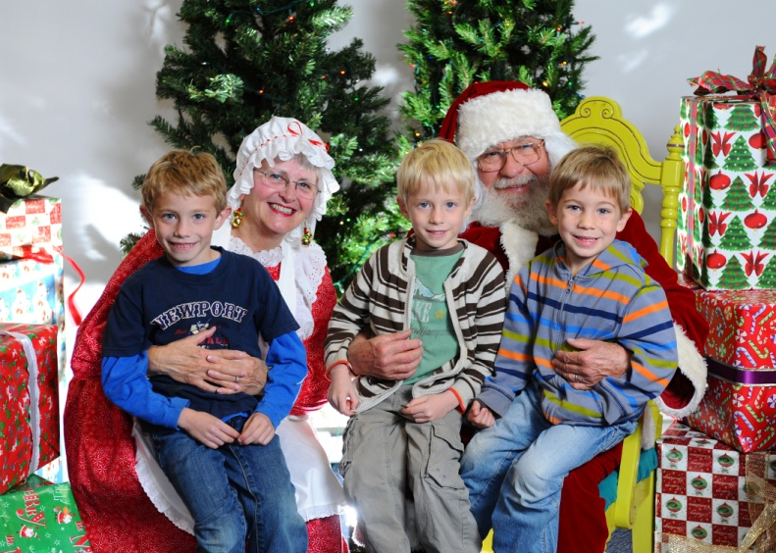
Monday, Dec. 19, 5:30 pm in the auditorium before the Concert performance at 7 pm
Shadow Mountain High School Auditorium ~ 2902 E Shea Blvd. FREE ADMISSION!

4x6 picture mounted on a festive paper frame or mailing card $5.00 ea
Digital copy sent to your email address $10.00 ea

Raffle Prizes! Tickets $2.00 Each or 6 for $10 Prizes available include a Family 4 pack tickets to Wet & Wild, Restaurant Gift Cards & more!

All Proceeds support the SMHS Band Program!

